Progress Report #2

20220827

Fang Wenqu

1. Theory
   1. Downloading Arduino IDE and DUE package
   2. void setup(): executed once; void loop(): executed over and over again until it is terminated
   3. digitalWrite(port_number, HIGH/LOW):

write through the port specified by the port number (e.g. 13). HIGH means 5V while LOW means 3V (built-in constant)

* 1. analogWrite(port_number, i) where i is an integer between 0 to 255. i = 255 corresponds to 5V while i = 0 corresponds to 0V.
  2. delay(number_of_milliseconds): indicate the number of milliseconds for which the current state is maintained
  3. Serial.begin(integer): sets the baud rate for serial data communication.
  4. Serial.print(): equivalent to printf(value, format)

1. Implementation
   1. On-Off:

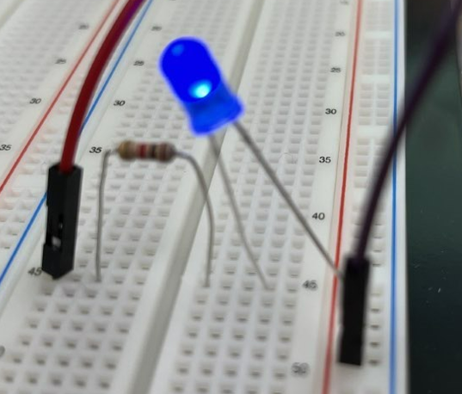

* 1. Fade

